**Gaminfinity SDK**

**Programming Guide**

**for**

**Unity3D**

V1.0.0.0

# History

|  |  |  |
| --- | --- | --- |
| Version | Date | Description |
| V1.0.0.0 | 2014-11-14 | 1st release |

# Description

Gaminfinity SDK Programming Guide for Unity3D is based on Gaminfinity SDK Programming Guide, which extends to support Unity3D.

The name of SDK this document describes is GaminfinitySdk4Unity3d.

Same as Gaminfinity SDK Programming Guide, GaminfinitySdk4Unity3d can be compiled in Mac and Windows, and runs in Android device and iOS device.

The contents in the GaminfinitySdk4Unity3d are shown as below

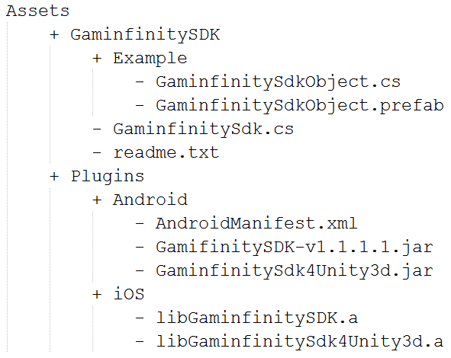

These files and folders are packed as one file: GaminfinitySdk4Unity.unitypackage.

# Quick Start

Download the GaminfinitySdk4Unity.unitypackage from http://...

Open Unity3D and create a new project

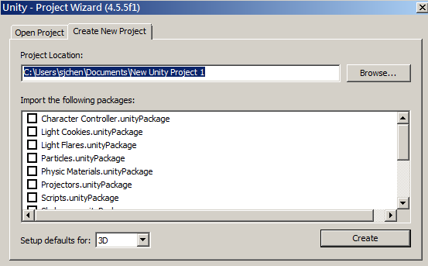

Import GaminfinitySdk4Unity.unitypackage to your new project

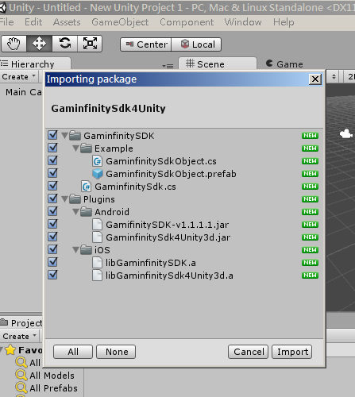

Drag and drop the GaminfinitySdkObject.prefab(in the path of Assets\GaminfinitySDK\Example) to your scene.

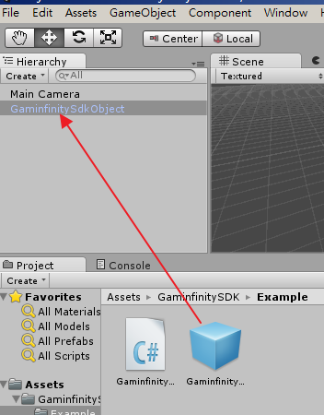

Configure necessary settings in Build Settings

For example, set up your bundle name, choose target device…, etc.

Connect your target device to your computer

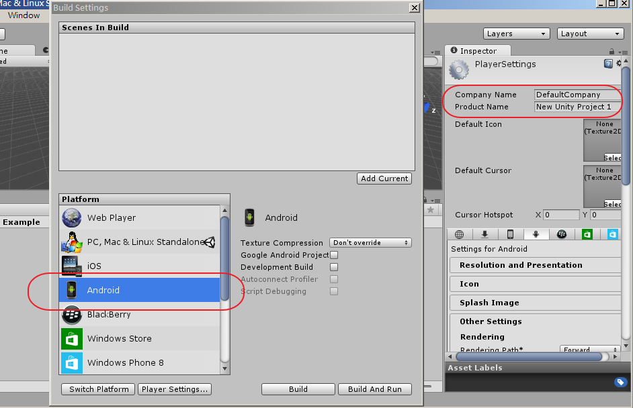

Build and Run

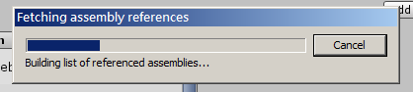

Click the button and get data from Gaminfinity SDK server

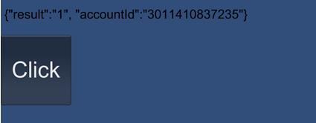

# Programming Guide

* 1. **Import package**

using com.gaminfinity;

**3.2 Call the method (one and only one method)**

GaminfinitySdk.getAccountId (accessToken, url);

If you are using Facebook login, please set the variable of accessToken a valid Facebook access token

, or just set accessToken to null for “Play Now”(without Facebook account binding) feature.

Set the url to the Gaminfinity SDK server’s url. Please connect the Gaminfinity’s technical person for correct url value.

**3.3 Setup callback function**

Once calling the method GaminfinitySdk.getAccountId (accessToken, url), the data will be returned and placed to the method name: void onGetAccountId(string msg) in the game object “GaminfinitySdkObject”

**Please note that the name of game object to retrived data from Gaminfinity SDK server server must be “GaminfinitySdkObject”**, because it is used for the callback object name from the SDK.

The data returned from Gaminfinity SDK server is in JSON format with two parts: one is the result, and another is the accountId to identify the user.

When the result is equal to 1, which means the calling is successful, and you can use the accountId as user id.

When the result is not equal to 1, which may has the following causes:

**Error code from Gaminfinity Server**

-1 parameter error

-2 invalid Facebook Access Token

-3 Facebook binding error

-99 Server internal Error

**Error code from Gaminfinity SDK**

-100 general error(including network error)

-101 server connection timeout(timeout=10 seconds)

-102 network disconnected

-103 network transport error

-104 data encryption/decryption error

-110 Internal Error

# Trouble Shooting

In Xcode IDE, add AdSupport.framework to library (Xcode -> TARGETS -> Build Phases -> Link Binary With Libraries)

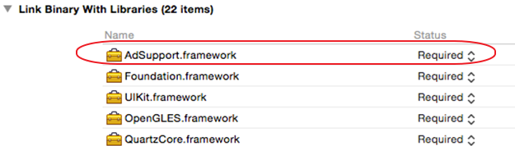

or an error message will be shown as below,

Undefined symbols for architecture armv7:

"_OBJC_CLASS_$_ASIdentifierManager", referenced from:

objc-class-ref in libGaminfinitySDK.a(GaminfinitySDK.o)

ld: symbol(s) not found for architecture armv7

clang: error: linker command failed with exit code 1 (use -v to see invocation)

